Jitter

🔄 What Is Jitter in Networking?
# Source: AI Source: Provided by: [Data Path: Persons Table -> ID Column: 1, Name_En Column: Motasem Essam] -> From: [ChatGPT] on [12/15/2025]
Jitter is the variation in the delay (latency) between data packets as they travel across a network. It measures how inconsistent packet arrival times are — even when packets are sent at regular intervals.

📦 Belongs to:
# Source: AI Source: Provided by: [Data Path: Persons Table -> ID Column: 1, Name_En Column: Motasem Essam] -> From: [ChatGPT] on [12/15/2025]
✅ Network Performance Metrics
Along with Latency, Bandwidth, Throughput, and Packet Loss

🧠 Definition:
# Source: AI Source: Provided by: [Data Path: Persons Table -> ID Column: 1, Name_En Column: Motasem Essam] -> From: [ChatGPT] on [12/15/2025]
Jitter is the difference in latency between successive packets — how much the delay time fluctuates.

📡 Example:
# Source: AI Source: Provided by: [Data Path: Persons Table -> ID Column: 1, Name_En Column: Motasem Essam] -> From: [ChatGPT] on [12/15/2025]
- 5 packets are sent every 1 second.
- If they all arrive 1 second apart → 0 ms jitter (perfect).
- If one arrives after 1s, then another after 1.5s, then 0.7s → jitter is present.

🎯 Why Jitter Matters
# Source: AI Source: Provided by: [Data Path: Persons Table -> ID Column: 1, Name_En Column: Motasem Essam] -> From: [ChatGPT] on [12/15/2025]
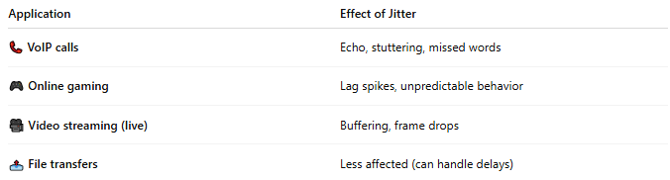
Application | Effect of Jitter
📞 VoIP calls | Echo, stuttering, missed words
🎮 Online gaming | Lag spikes, unpredictable behavior
🎥 Video streaming (live) | Buffering, frame drops
📤 File transfers | Less affected (can handle delays)

📏 Acceptable Jitter Values
# Source: AI Source: Provided by: [Data Path: Persons Table -> ID Column: 1, Name_En Column: Motasem Essam] -> From: [ChatGPT] on [12/15/2025]
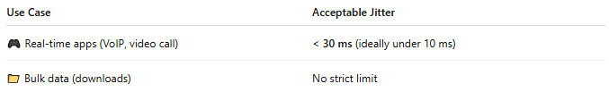
Use Case | Acceptable Jitter
🎮 Real-time apps (VoIP, video call) | < 30 ms (ideally under 10 ms)
📁 Bulk data (downloads) | No strict limit

📉 What Causes Jitter?
# Source: AI Source: Provided by: [Data Path: Persons Table -> ID Column: 1, Name_En Column: Motasem Essam] -> From: [ChatGPT] on [12/15/2025]
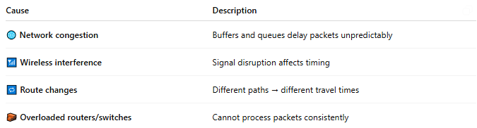

Cause | Description
🌐 Network congestion | Buffers and queues delay packets unpredictably
📶 Wireless interference | Signal disruption affects timing
🔁 Route changes | Different paths → different travel times
🧱 Overloaded routers/switches | Cannot process packets consistently

🛠 How to Measure Jitter
# Source: AI Source: Provided by: [Data Path: Persons Table -> ID Column: 1, Name_En Column: Motasem Essam] -> From: [ChatGPT] on [12/15/2025]
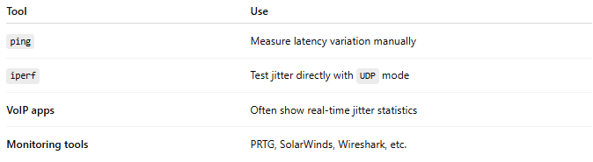

Tool | Use
ping | Measure latency variation manually
iperf | Test jitter directly with UDP mode
VoIP apps | Often show real-time jitter statistics
Monitoring tools | PRTG, SolarWinds, Wireshark, etc.

✅ How to Reduce Jitter
# Source: AI Source: Provided by: [Data Path: Persons Table -> ID Column: 1, Name_En Column: Motasem Essam] -> From: [ChatGPT] on [12/15/2025]
- 🛠 Upgrade network equipment (routers/switches)
- 📶 Use wired connections instead of Wi-Fi
- 🚦 Enable Quality of Service (QoS) to prioritize real-time traffic
- 🔧 Avoid network congestion and overloaded links
- 🛰 Use jitter buffers on VoIP systems

📌 Summary
# Source: AI Source: Provided by: [Data Path: Persons Table -> ID Column: 1, Name_En Column: Motasem Essam] -> From: [ChatGPT] on [12/15/2025]
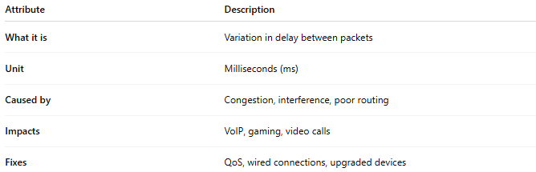
Attribute | Description
What it is | Variation in delay between packets
Unit | Milliseconds (ms)
Caused by | Congestion, interference, poor routing
Impacts | VoIP, gaming, video calls
Fixes | QoS, wired connections, upgraded devices

